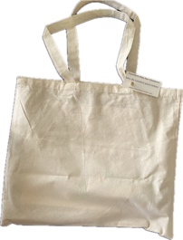
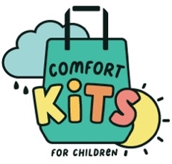

Comfort Kits for Children – Description of Contents

Comfort Kits for Children
Canvas tote bag contains a small organza gift bag for crayons, mood ring.

Remaining items (see below) go into the large tote bag. A printed pamphlet of instructions is also included.

Our printer ready pamphlet (pdf form) is emailed to donor group. They print and add to each Comfort Kit tote bag.

Contents of Comfort Kits:
- Two animal finger puppets
- Bottle (3 oz) of soap bubbles
- Mini squeeze “stress” ball (universal theme like stars/night sky; no smiley faces) OR small tub of slime.
- Crayons or pre-sharpened colored pencils (if plain pencil added, include sharpener)
- Small blank notebook/journal
- Mood ring OR 5-10 biodots and explanation card
- Blank, pre-folded, box (large enough to hold journal and other items) to decorate.
- Sheets of stickers (animals or nature themed) to use as decorations for plain box that becomes their “treasure box.”

